Explorobot: A Simulated Neuronal Network Robot with Neurodegenerative Disease
John Blood
Florida Institute of Technology

Executive Summary
The general principles of how neurons function can be transferred to electronics. Neurons
function by creating an ion gradient by pumping sodium to the other side of its membrane using a
sodium potassium pump. When a neuron is fired upon ion gates open allowing ions to rush back inside the neuron resulting in a change of voltage. The change in voltage if significant enough will trigger other ion gates to open and the electrical signal to propagate down and fire upon the next neuron. A program written in C++ could be used to simulate this behavior. This could be scaled to multiple neurons to create a simulated neural network. The simulated neural network can be used to demonstrate how neuronal networks can be used to create complex behavior. The neurons were given a limited amount of energy which results in neurons dying to demonstrate the effects of neurodegenerative disease on neuronal circuits. To provide the simulated neurons a stimulus and an output, the code will be used in a simple robot with proximity sensors and motors.

Introduction
Neurons adhere to two main principles, rate law and specific energies. Neurons use rate to convey intensity of a signal. The meaning of a signal is determined by which neurons are firing. Neurons form an ion concentration difference across the neuronal membrane by using a sodium potassium pump. The concentration difference of the ions results in a voltage across the neuronal membrane. Neurons form synapses with other neurons to form circuits. Within these synapses neurotransmitters are released and bind to receptor sites. These receptor cites open or prevent the opening of ion channels. The opening of ion channels can be either excitatory or inhibitory depending on which ions the channel allows to pass (Carlson, 2013).
Neurons can be represented using code that use variables to represent the aspects of neurons. Using code to simulate neurons allows for the simulation of neuronal circuits. To make the code interesting and visualize what is happening it can be used to create neuronal circuits that result in complex behavior in a robot. Neurons can be given a limited amount of energy using a variable and stop functioning when the value of the variable reaches zero to simulate cell death from hypoglycemia. The same behavior could be achieved much easier and more efficiently by using more traditional algorithm, the simulation of neurons to control the robot is entirely for educational purposes to demonstrate what behavior can result from different types of neuronal circuits and the effects of cell death on a neuronal circuit.
Research Objective
The objective of using a simulated neuronal network to control a robot is to create a visual demonstration of a neuronal circuit. Simulating a neuronal network is not expected to have any benefits over using an alternative code methods and is expected to be less efficient. Using a simulated neuronal network to control a robot is for demonstration and educational purposes of how neurons behave and how they can interact to result in complex behavior. The main goal is to model the basic functions of neurons using code. To make the code interesting it is applied the same way that makes actual neurons interesting in life forms, sensation and behavior, by using it in a simple robot with proximity sensors and motors.
Motivation and Background
The project originally started as a code project with no intention of it being used to control a robot or have meaningful neuronal circuits. The original program's goal was to simulate the ion concentration of neurons. This project was inspired by learning to code while also learning neuronal physiology. When writing the code a problem occurred, to have the neurons do something they needed input and to see what they were doing they needed an output. A random number generator as the input and printing text in the terminal worked as a temporary solution however, to make the code more interesting I mimicked what made neurons interesting in life forms by adding sensors and motors. Once sensors and motors were added the code had to be ported to a microcontroller and the neurons had to be connected in a meaningful way. The need for something to provide input to the neurons and something for the neurons to act on resulted in the Explorobot.
Implementation
To simulate a neuronal network C++ will be used. An array of structures will be used to simulate each neuron. The code will be run in an Arduino. Due to Arduinos being single core and unable to process the neurons in parallel loops are used as a task scheduler. First the open gates are calculated for all of the neurons, then the new voltage of each neuron based on the number and type of open ion gates, then all of neuron's are flagged as fired or unfired, then action takes place for motor neurons that fired. To create neuronal circuits a synapses function is used to define which ion gates open depending on which neurons previously fired. To visualize the code running and create an objective for why neurons are connected the way they are it will be used to control a robot. The components of the robot that the code will interact with consist of two motorized wheels and six proximity sensors.

Hardware
A pre-built robot chassis was used to save time and focus efforts one the code rather than the hardware. The chassis consist of an acrylic sheet of plastic, two motors each with one wheel, and one swivel wheel. Velcro was used to secure a 9V battery pack to the chassis as well as six proximity sensors, three in the front and three in the back. On top of the battery pack an Arduino Mega in an acrylic case was secured with Velcro. The Arduino Mega was used because it has more available gpio pins than some other Arduino models and because Arduinos are a common microprocessor making them very accessible. The Arduino Mega is connected to the motor shield by GPIO, VIN, and Ground pins. The six proximity sensors connect directly to twelve GPIO pins and the 5V and ground pins on the Arduino Mega. The Arduino motor shield was used for simplicity to focus on the code rather than the electronic components. The motor shield connects to the motors and to a 9V battery pack consisting of six AA batteries. The motor shield has two pins used to set the direction for the motors to spin, two pins to set the speed using PWM, two pins used to engage or disengage breaks, and two pins used to sense the current from each wheel. A complete bill of materials is below.

The Code
The code consist of fourteen functions: void setup, void init_neuron_data, void initneurons, void loop, void ping, long microsecondsTocm, void sensory, void synapses, void neuron, void setconcentration, void pump, void check, void fire, and void motorcontrol. Because the Arduino cannot process neurons at the same time a task scheduler is used to sweep through each neuron at each stage of processing. To set up the Arduino and start the program the setup function sets the pins on the Arduino as either input or output, then the neuron structures are created with the ini_neuron_data function, and finally the neurons are set to resting potential.
The program then begins in the loop function which acts as the main function but will repeat in a loop rather than return any value. The ping function then collects data from each sensor which is converted into useful information by the microsecondsTocm function and the sensory function. The synapse function opens ion gates based on which neurons fired the previous cycle, the first cycle nothing will happen. The neuron function then runs once for each neuron by passing each neuron's id into the setconcentration function, then pump function, and the check function. These functions set each neurons concentration based on which and how many ion gates were opened by the synapse function, the pump works against this trying to maintain resting potential and expends limited energy, and the check flags neurons that reached their excitatory threshold.
Finally the fire function converts neuronal data into information useful to the motor shield and then calls the motorcontrol function to activate, deactivate, or change the PWM values for the pins the motor shield uses. After this the program restarts at the ping function. Each time the pump is used in a neuron, the value of a variable called ATP is decreased. Once a neuron is out of ATP that neuron can no longer function. The source code and a flowchart can be found in the appendix. The code can be manipulated fairly easily to see how different synaptic strengths effect the circuits or to create new circuits. A flowchart of the functions in the code is shown in Figure 1 and the complete source code in Appendix A. This code is used to create an array of structures that function as virtual neurons that interact with one and other as a neuronal circuit.

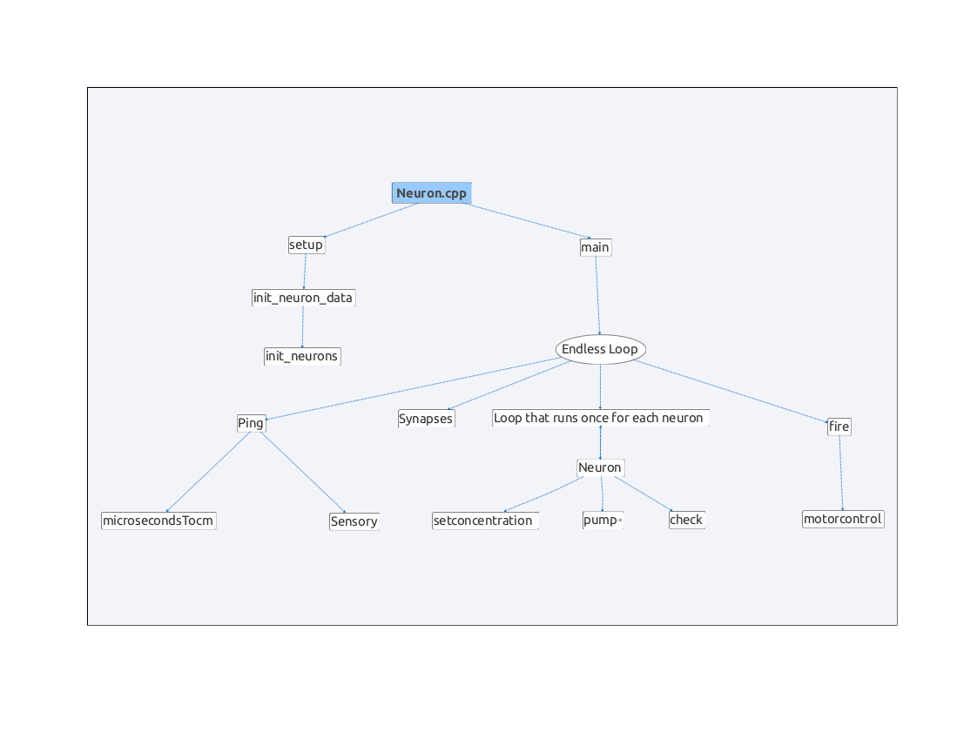Figure 1: Code Chart- Code chart of the flow of functions read top to bottom and left to right.

Virtual Neurons
Neuronal Structure:
The neuron structure consist of the neuron's id number, the amount of available ATP, the neuron's current state (alive or dead), the current ion concentration, if the neuron has fired or not, the number of sodium gates open, and the number of potassium gates open. The values of these variables changing by the functions is used to simulate neuronal function. Some constant integers are used to define other characteristics. The number_of_neurons integer defines how many neurons should be created, resting_potential defines the resting potential of the neurons, threshold defines the excitatory threshold for the neurons, hyperpolarized defines the concentration of the neurons after they recover from firing, pumprate defines the rate at which ions are pumped by the sodium potassium pump, and leakrate defines the rate at which ions will leak out of a hyper polarized neuron. The synapse strengths are also defined in the following constant integers: speedexcite, speedinhibit, epiexcite, epiinhibit, directionexcite, directioninhibit, directionmodulator. Figure 2 depicts the basic components of a neuron that this structure attempts to simulate.
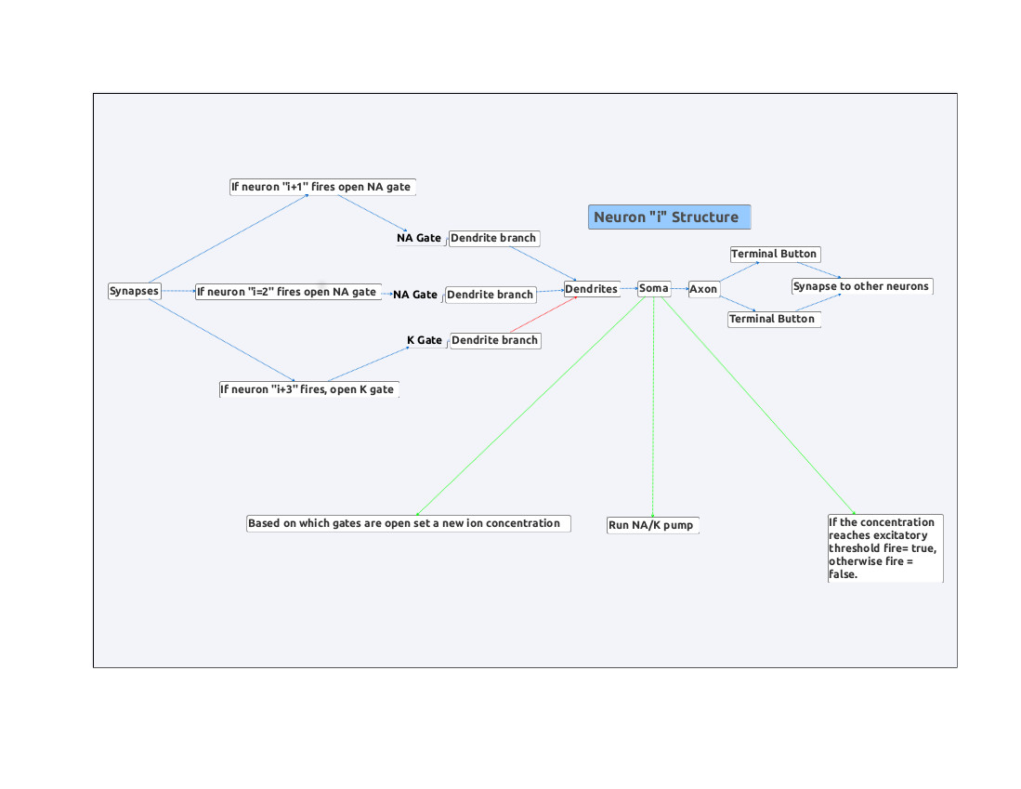Figure 2: Neuronal Structure- Code is used to create a structures that simulates the basic components of neurons. This figure demonstrates an example neuron which contains two excitatory and one inhibitory inputs from other neurons.

Neuronal Circuits
The connections in the synapses function result in two primary circuits, direction and speed, and one modulating circuit, direction-speed. These circuits are used to interpret sensory input and actuate behavior in the robot. The behavior they produce is the robot turns towards empty space by changing wheel speed and reversing direction if it gets too close to an object. The complete circuit can be seen in Figure 3.

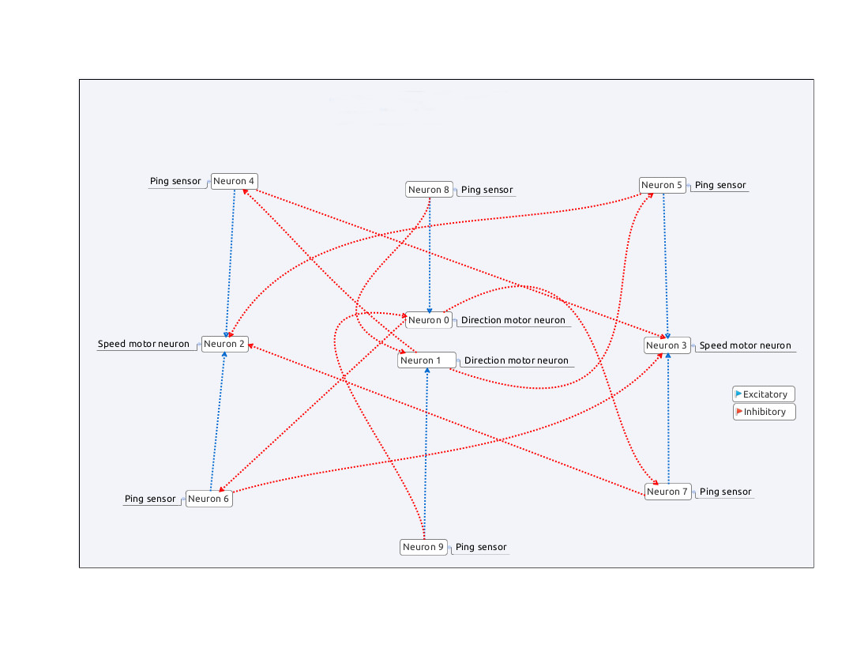Figure 3: Complete Neuronal Circuit- The complete neuronal circuit. Red lines indicate inhibitory connections and blue lines indicate excitatory connections.

Direction Circuit:
The direction circuit (Figure 4) consist of four neurons, one that fires based on the front center proximity sensor (Neuron 8), one that fires based on the rear center proximity sensor (Neuron 9), one that sets the direction forward when it fires (neuron 0), and one that sets the direction to reverse when it fires (neuron 1). Neuron 8 is inhibitory to neuron 1 and excitatory to neuron 0. Neuron 9 is excitatory to neuron 1 and inhibitory to neuron 0.

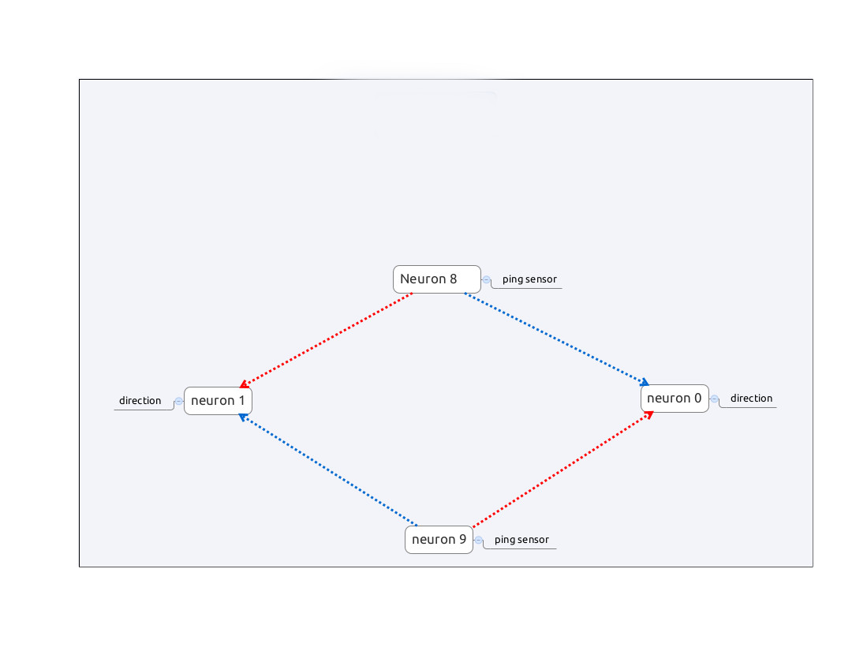Figure 4: Direction Circuit- This indicates the neurons used to control direction in the robot. Direction can be seen as a state with a flip flop switch.

Speed Circuit:
The speed circuit (Figure 5) consist of six neurons. Four of the neurons receive information from the proximity sensors on the sides and two increase the PWM value sent to their wheel when they fire. The the four neurons attached to the pinger are excitatory to the neuron that controls the wheel on the same side as the proximity sensors they receive information from and inhibitory to the neuron that controls the wheel on the other side.

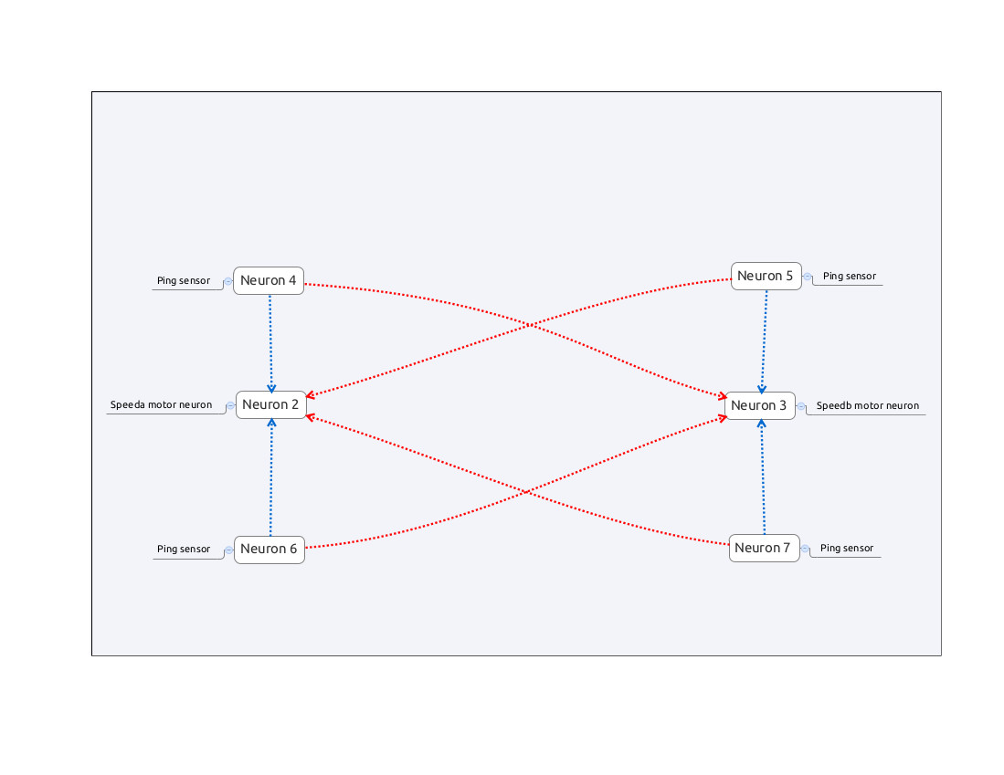Figure 4: Speed Circuit- The speed circuit uses rate law to change the PWM value sent to the motors. The excitation on the same side and inhibition to the other side results in the robot turning away from obstacles.

Speed-Direction Modulating Circuit:
The speed-direction modulating circuit is used to prevent irrelevant sensor data from the current rear of the robot from interfering with the speed. This circuit consist of six neurons, the direction controlling neurons, and the neurons which receive input from the left and right proximity sensors on the front and back. Each direction neuron is inhibitory to the neurons that get data from the rear (relative to the current direction) sensors.

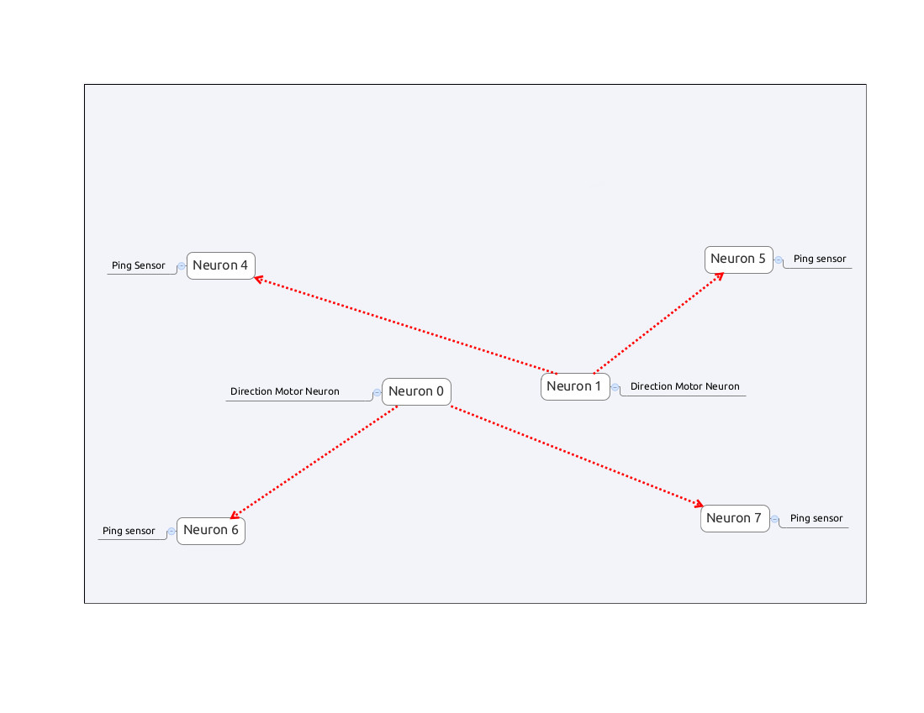Figure 5: Speed-Direction Circuit- The speed direction circuit is used to inhibit signals from the sensors involved in wheel speed that are on the back of the robot relative to its current direction.

Alternative Non-Neuronal Code
Code that does not simulate neurons can be used to create similar behavior as the code mentioned above. This code can be seen in Appendix B and can be useful for understanding what the logic of the neuronal circuit is. The logic that results in similar behavior to the direction neuronal circuit is as follows: If the current direction is forward and the front center sensor is less than the rear center sensor and the front center sensor is less than thirty centimeters then change the direction to reverse. If the current direction is reverse and the rear center sensor is less than the front center sensor and the rear center sensor is less than thirty centimeters then change the direction to forward. The code that behaves similarly to the speed neuronal circuit is as follows: If the current direction is forward and the front left sensor is less than the front right sensor increase the speed of the left wheel. If the front left sensor is greater than the front right sensor then increase the speed of the right wheel.
Experiment 1
Method
To compare the alternative code to the neuron inspired code the Explorobot was placed in the same starting location, a hallway that leads to an open room with an obstacle in the middle. The first trial used the alternative code, the second trial used the neuron inspired code. Tape was used to mark the starting location to ensure consistency. Each trial lasted five minutes of allowing the Explorobot to explore. Each trial was filmed and compared side by side and compared on the following measures: Path taken, obstacles hit, times it got stuck, and unexpected erratic behaviors such as driving in a circle.

Results

Experiment 2
Method
To compare the Explorobot with and without simulated neurodegenerative disease it was placed in the same starting location, a hallway that leads to an open room with an obstacle in the middle. The first trial used the neuron inspired code without neurodegenerative disease and the second trial used neuron inspired code with simulated neurodegenerative disease. Tape was used to mark the starting location to ensure consistency. Each trial lasted five minutes of allowing the Explorobot to explore. Each trial was filmed and compared side by side and compared on the following measures: Path taken, obstacles hit, times it got stuck, and unexpected erratic behaviors such as driving in a circle.
Results
Discussion
Conclusions
Future Work
This code can be re-purposed to make other neuronal circuits. Future work using this code includes making a neuronal circuit which mimics the flip flop circuit used for RAM to create memory with neurons, a neuronal circuit which uses a stepper motor to turn one proximity sensor rather than using six fixed position proximity sensors, a neuronal circuit in a grid used to map the robots spatial environment. Additional work can be done to improve realism of the code in simulating neurons and to specify different types of neurons based on the different types of neurons found in lifeforms.

References
Carlson N.R. (2013). Foundations Of Behavioral Neuroscience, 9. Upper Saddle River, New Jersey: Pearson.
Ultrasonic Ranging Module HC – SR04 http://www.micropik.com/PDF/HCSR04.pdf (format later)
http://arduino.cc/en/Main/ArduinoMotorShieldR3 (format later)

Appendix A
Insert most recent code

Appendix B
Insert Alternative Code

